**HUD Styles in other types of platform games:**

**Mark Of The Ninja:**

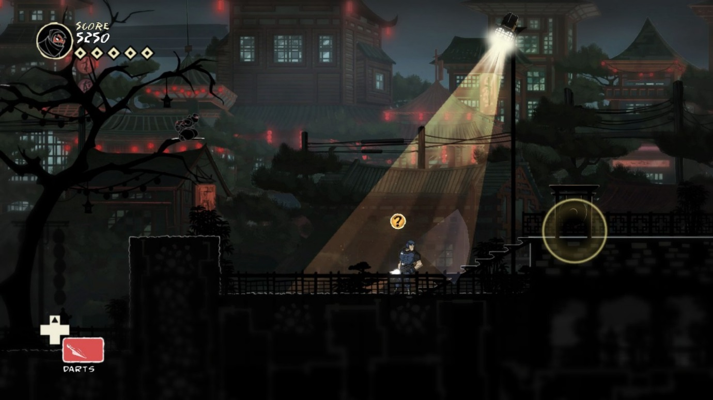

In games such as ‘Mark of the Ninja’ there isn’t too much clutter on the screen while playing, only an *Item* selection (Seen in the bottom right) along with a health meter and score counter (seen on the top left). Having this choice of minimal HUD allows the player to see more of the level allowing enemy placement as well as cover and traversal opportunities to become more apparent whilst also immersing the player in the world more.

Mark of the Ninja also takes an interesting approach to UI by making certain things appear in-game, for example, when the player character is in cover and not visible to enemies then it will turn dark and blend in more with the background, this is a player affordance since they blend in it would make sense for the enemy not to see them. Enemy sightlines are also shown by a white cone shape that is displayed in front of them giving the player an area where they know is not good to enter.

All of these things build up what is generally quite a good HUD system, although it’s visual weighting is very much on the left side, this leads to the right hand side of the screen looking very empty so if we go for a very basic HUD in our game it would look better to spread the elements over both left and right sides to make it look more appealing to the player.

**Rayman Legends:**

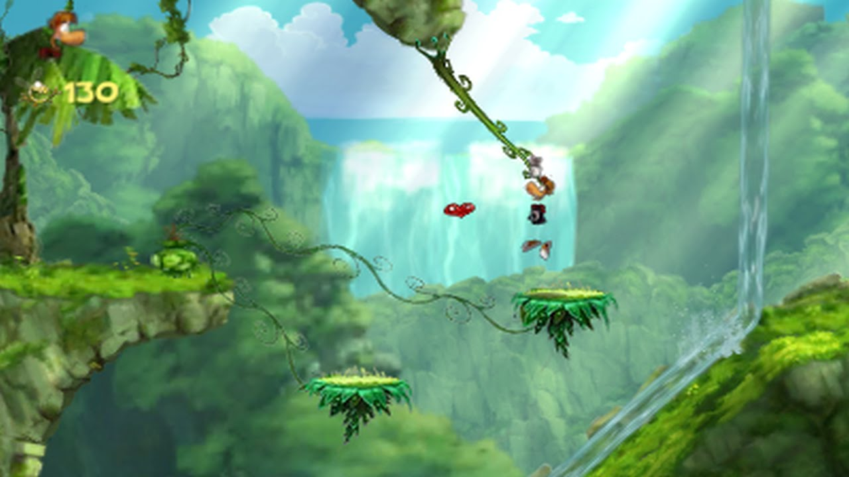

In Rayman Legends, there’s also very little in terms of HUD design since there’s not actually much for the player to know since it’s a game where you die in one hit there’s no need for a health bar and if you do pick up some extra health it hovers around the character until they lose it from being hit by an enemy. The only thing in terms of a HUD in the game is in the top left there is a *Lum* counter (Lums being the collectables in the game).

I think this approach to the HUD is a lot cleaner and more relatable to our game since there is going to be very little in terms of gameplay mechanics since we’re trying to keep it quite basic, this will allow more of the screen to be shown for traversal and enemy avoidance.

**Possible Fonts:**

<https://www.dafont.com/alien-robot.font>

* Sleek, easy to read, mechanical styling

<https://www.dafont.com/aged-machine.font>

* Easy to read, looks aged

<https://www.dafont.com/army-rust.font>

* Not as easy to read, fits the military styling for the game

<https://www.dafont.com/vintage-warehouse.font>